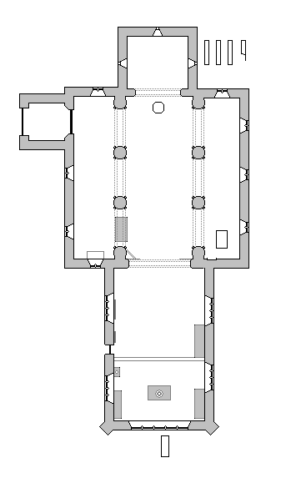
11
11
1
2
3
12
7
4
5
6
8
9
10
TOWER
Norman
- c.1180
NAVE
Early English
- c. 1240
CHANCEL Perpendicular - c.1500
A plan of the church of St Mary the Virgin, Marholm.(Not to Scale.)
KEY

1. The Font

2. Knight’s Tomb

3. Lady Altar

4. Tomb the first Sir William Fitzwilliam died 1534.

7. William, First Earl Fitzwilliam died 1719 and his wife

8. Memorial to Evelyn Wentworth Fitzwilliam

9. Memorial to The Hon. Lady Hastings

10. 14th century floriated grave slabs

11. North And south Aisles

12. Fitzwilliam memorials at the East End outside the Church.

5. Sir William Fitzwilliam died 1599 and his wife Ann, daughter of Sir William Sidney. This Sir William Fitzwilliam was Lord Lieutenant of Ireland under Queen Elizabeth 1st.

6. Monument to Edward Hunter alias Perry died 1646

